Ali Ata Hashmi
Assistant Director (Admin)
Tuesday, 18 February, 2025, 4:10:10 PM
Tuesday, 18 February, 2025, 4:10:10 PM


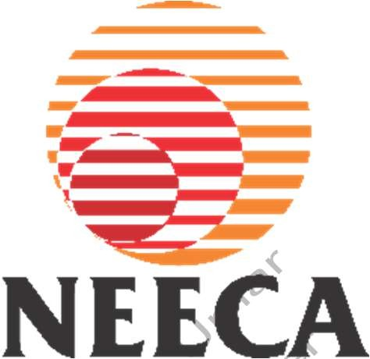
TERM OF REFERENCE
HIRING OF CONSULTING FIRM/INSTITUTE/CORPORATE ENTITY FOR DEVELOPMENT OF A REGULATORY FRAMEWORK FOR ENERGY SERVICE COMPANIES (ESCOS) IN PAKISTAN
Ali Ata Hashmi
Assistant Director (Admin)

Contents
Tuesday, 18 February, 2025, 4:10:10 PM
Tuesday, 18 February, 2025, 4:10:10 PM
Abbreviations III
- Introduction 4
- Objective of the Assignment 4
- Scope of Work 4
  - Comparative Analysis of ESCO Regulatory Frameworks 4
Ali Ata Hashmi
  - Regulatory Framework Development 5
Assistant Director (Admin)

  - Financial Mechanisms 5
- Deliverables & Accountabilities 6
- General Instructions 7
- Duration of Contract 8
- Eligibility 8
- Deadline to Submit Proposal 9
- Mandatory Contents of Proposal 9
Annexure D 11
Ali Ata Hashmi
Assistant Director (Admin)

Abbreviations
NEECA | National Energy Efficiency and Conservation Authority
ESCO | Energy Service Company
FBR | Federal Board of Revenue
ATL | Active Taxpayer List
SECP | Security Exchange Commission of Pakistan
SOW | Scope of Work
M&V | Measurement and Verification
Ali Ata Hashmi
Assistant Director (Admin)
Tuesday, 18 February, 2025, 4:10:10 PM
Ali Ata Hashmi
Assistant Director (Admin)
Tuesday, 18 February, 2025, 4:10:10 PM

Introduction:
Tuesday, 18 February, 2025, 4:10:10 PM
Tuesday, 18 February, 2025, 4:10:10 PM
Pakistan faces significant challenges in optimizing its energy demand, improving energy efficiency, and reducing greenhouse gas emissions. Energy Service Companies (ESCOs) have successfully addressed these challenges in numerous countries through performance-based contracts and provided measurable energy savings while mitigating financial risks for clients.
Despite the potential for significant energy savings and emissions reduction, the ESCO market in Pakistan remains nascent due to the absence of a supportive regulatory environment. This situation inhibits the development of innovative energy solutions and limits access to financing for energy efficiency projects.
Ali Ata Hashmi
Assistant Director (Admin)
Recognizing these barriers, the National Energy Efficiency and Conservation Authority (NEECA), seeks to establish a robust regulatory framework to enable and sustain the ESCO market. This initiative aims to foster private sector participation, mobilize financial resources, and build the technical capacity required to meet Pakistan's energy efficiency goals.
To facilitate this essential process, NEECA is seeking the services of a qualified consulting firm/institution/corporate entity for developing comprehensive ESCO regulatory framework for Pakistan.
The ideal firm/institute/corporate entity must have a team of qualified professionals, including energy sector experts, regulatory specialists, legal advisors, financial analysts, policy experts, and technical consultants with expertise in energy efficiency, conservation, and development of business models.

Objective of the Assignment:
Ali Ata Hashmi
The consulting firm/corporate entity will develop a comprehensive, sustainable, and practical ESCO regulatory framework for Pakistan that facilitates legal, financial, and operational support for ESCOs. The regulations will aim to standardize ESCO practices, protect stakeholders, and promote energy efficiency investments.
Assistant Director (Admin)

Scope of Work:
The consulting firm/Corporate entity will carry out the following activities:

Comparative Analysis of ESCO Regulatory Frameworks:
    - Conduct a benchmarking study of successful ESCO regulatory frameworks in countries with similar socio-economic and energy profiles.
    - Identify and recommend best practices in areas such as financial structuring, M&V protocols, and stakeholder coordination.

Regulatory Framework Development:
Tuesday, 18 February, 2025, 4:10:10 PM
Tuesday, 18 February, 2025, 4:10:10 PM
    - Conduct a thorough review of Pakistan’s existing energy policies, regulations, and legal frameworks related to energy efficiency and conservation specifically the National Energy Efficiency and Conservation Act 2016.
    - Based on the review, develop comprehensive regulations addressing key areas:
      - Licensing requirements and operational standards for ESCOs.
      - Roles and responsibilities of stakeholders, including NEECA provincial designated agencies i .e. Punjab Energy Efficiency and Conservation Agency, Sindh Energy Efficiency and Conservation Agency, Baluchistan Energy department, Khyber Pakhtunkhwa Energy Organization, financial institutions, and end-users.
Ali Ata Hashmi
Assistant Director (Admin)
      - Provisions for performance-based contracting, including terms for shared savings, guaranteed savings, and full-service energy contracts.
      - Dispute resolution mechanisms to address conflicts between parties.
      - Risk-sharing frameworks to mitigate financial and operational risks.
      - Propose mechanisms for monitoring, enforcement, and periodic updates of regulations.

Financial Mechanisms:
    - Design and recommend financial models, such as:
      - Third-party financing options (e.g., banks and private investors).
      - Risk mitigation tools, including performance guarantees and insurance mechanisms.
      - Tax incentives, subsidies, or grants for energy efficiency projects.
    - Develop an effective framework for Measurement and Verification (M&V) protocols based on international standards such as IPMVP (International Performance Measurement and Verification Protocol).
Ali Ata Hashmi
Assistant Director (Admin)
    - Provide guidelines to streamline financing approvals for ESCO-based projects, including templates for performance contracts.

Consultative sessions / Capacity Building
    - Develop a roadmap for organizing consultative sessions / capacity building at Islamabad, Karachi, and Lahore targeting:
      - ESCO operators to enhance technical and financial management capabilities.
      - Regulatory and governmental bodies to ensure effective policy implementation and oversight.
      - Financial institutions to familiarize them with ESCO models and related risk factors.

    - Organize stakeholder engagement workshops to gather feedback and promote collaborative development.
Assistant Director (Admin)
Tuesday, 18 February, 2025, 4:10:10 PM
Ali Ata Hashmi
Assistant Director (Admin)
Tuesday, 18 February, 2025, 4:10:10 PM

Deliverables & Accountabilities:
  - The firm/institute is required to deliver the following as per chronology.
Ali Ata Hashmi

Sr.  No. | Deliverable Description | Timeline  (From the Completion of Previous Deliverable) | Percentage Completion of the Contract
1. | Evaluation/Assessment report on existing frameworks and global best practices, identifying the most suitable model for Pakistan with a detailed analysis. | 20 days from Signing of Contract | 15%
2. | Detailed regulations governing ESCO operations in Pakistan, including legal, financial, and technical guidelines along with comprehensive documentation on financial models, M&V protocols, and risk mitigation strategies. | 40 days | 50%
3. | Detailed roadmap for Consultative/Capacity building sessions as per the scope on the draft ESCO regulations along with the supporting material i.e. presentations, list of stakeholders/invitees, feedback forms etc. | 10 days | 10%
4. | Conduct of consultative / capacity building sessions, submission of session reports and consolidated regulations with all the documents, forms, template etc. incorporating stakeholder feedback and recommendations. | 20 days | 25%

  - Any task mentioned in the Scope of Work but not explicitly listed in the Deliverables shall still be considered part of the required deliverable.
Tuesday, 18 February, 2025, 4:10:10 PM
Tuesday, 18 February, 2025, 4:10:10 PM
  - NEECA shall provide response to general submissions of the Consulting Firm within 10 working days from the date of receipt of submission for approval.
  - Expenses and arrangements for travelling boarding & lodging for deliverable 3 shall be arranged by a consulting firm/corporate entity.
  - The consulting firm or corporate entity, with NEECA's mutual consent/approval, will be responsible for arranging the venue for the consultative session.
  - The consulting firm/corporate entity is required to submit soft editable copies of all the documents and presentations under the contract.
Ali Ata Hashmi
Assistant Director (Admin)
  - The consulting firm/corporate entity is required to
    - attend in-person meetings on prior notification
    - attend virtual meetings as and when required by NEECA
    - prepare and deliver presentations relevant to the tasks assigned in the contract

General Instructions:
  - The consulting firm/Corporate entity must abide by laws of Pakistan during completion of the contract.
  - The consulting firm/Corporate entity shall not use any material / content which has copyrights of others or proprietary of others.
  - All the material, documents, content, handed over to NEECA shall be property of NEECA and the consultant shall have no proprietary rights of this material.
  - The consulting firm/Corporate entity may claim payment on successful completion of each deliverable by submitting complete and verifiable invoice. The payment shall be made within thirty (30) calendar days of receipt of a complete and verifiable invoice.
Ali Ata Hashmi
Assistant Director (Admin)
  - If the leading firm / corporate entity does not have all the expertise for the conduct of assignment, there is no objection to the lead firm / corporate entity associating with other firms or entities not bidding on their own or associating with other bidders for the purpose of this assignment. In such a case, the proposal must include an undertaking of association from the associating firm(s)/ Corporate entities(s) (Sample of undertaking is attached) as Annexure-D.
  - The consulting firm/corporate entity shall not sublet the task to any other individual or sub-consultant without prior approval of NEECA.
  - The consultant shall be required to maintain confidentiality and avoid breach of data & content deliverable under the contract.

  - All the costs for completing the contract are to be borne by the consulting firm/cooperate entity.
Tuesday, 18 February, 2025, 4:10:10 PM
Tuesday, 18 February, 2025, 4:10:10 PM
  - A penalty of 0.1% per day of the lump sum contract value shall be applicable in case of delay in completion of contract except for the reasons which are not attributable to the consultant.
  - In case of breach of the conditions of the contract, NEECA reserves the right to black- list the consultant in record of NEECA and initiate necessary legal action.
  - Either Party shall be excused from any delay or failure in performance required hereunder if caused by reason of any occurrence or contingency beyond its reasonable control, including, but not limited to, acts of God, acts of war, fire, insurrection, strikes, lock-outs or other serious labor disputes, riots, earthquakes, floods, explosions or other acts of nature.
Ali Ata Hashmi
Assistant Director (Admin)
  - Either party may terminate this agreement at any time by providing the other party with seven (7) calendar days written notice. The NEECA may terminate this agreement immediately at any time if the consultant fails to provide service or breaches any other material term of this agreement.
  - NEECA reserves the right to reject all proposals without assigning any reason.

Duration of Contract:
90 Calendar Days from date of signing of the Contract

Eligibility:
The consulting firm/corporate entity submitting the proposal must meet the following eligibility criteria.
Ali Ata Hashmi
Assistant Director (Admin)
  - Must be registered in Pakistan with relevant Authorities and Departments
  - Must be a well-established and reputable entity having 10 years of experience with a minimum of five (05) years of proven experience in developing regulatory frameworks, policies, or guidelines for the energy sector. Firms with extensive experience at both national and international levels will be given preference.
  - Must have successfully completed at least two (02) projects related to the development of regulatory frameworks, policies, or guidelines for energy efficiency, conservation, or related fields.

  - Must have a team of qualified professionals, including an energy sector expert, regulatory and policy specialist, legal advisor, and a financial analyst, each possessing a minimum of five years of experience in their respective fields.
Tuesday, 18 February, 2025, 4:10:10 PM
Tuesday, 18 February, 2025, 4:10:10 PM
  - Must have the familiarity with Pakistan’s energy sector and institutional landscape and detailed knowledge of international energy efficiency standards and practices.
  - Must not be contracts or have any proprietary shares of the firms or institutes interested to be registered under the proposed regulations.

Deadline to Submit Proposal:
<19th March 2025> at 11:00 HRS
Ali Ata Hashmi
Assistant Director (Admin)
The bids shall be opened after 30 minutes of the proposal submission deadline

Mandatory Contents of Proposal:
The proposal to be submitted by the interested bidder must contain the following, otherwise the proposal may be considered non-responsive.
  - Proposal compromising on the expertise of the bidder (excluding letters of association, if any) highlighting the corporate capability of the bidder, including
    - The year and state/country of incorporation
    - A brief description/overview of the bidder’s past and present activities
    - Evidence of at least two previously completed similar nature of projects
    - Detailed work plan for successful completion of the contract.
(Publicity material such as brochures and other printed matters should not be included in the proposal.)
Ali Ata Hashmi
Assistant Director (Admin)
  - A financial proposal i.e. Lump sum bid value inclusive of all applicable taxes in PKR
  - Registration certificates i.e. PPRA, SECP & FBR and ATL status.
  - If the bidder is a consortium, joint venture or association of two or more legal entities, this should be clearly stated, the lead entity clearly identified, and an association letter as per Annexure-D, addressed to the lead entity by its partners included in the proposals.
  - Joint Venture Agreement in case of consortium of firms/members.
  - Affidavit on judicial paper that the firm has never been backlisted, 2% Bid Bond (demand draft/ pay order) in favor of “National Energy Efficiency and Conservation Authority-NEECA” and Correctness of information.
  - CV of the personnel going to be involved in the activity i.e. at least one energy sector expert, one policy and regulatory specialist, one legal advisor, and one financial analyst

having a minimum of 7 years of experience in their respective fields along with work experience certificates.
Ali Ata Hashmi
Assistant Director (Admin)
Tuesday, 18 February, 2025, 4:10:10 PM
Ali Ata Hashmi
Assistant Director (Admin)
Tuesday, 18 February, 2025, 4:10:10 PM
*****

Annexure D
Tuesday, 18 February, 2025, 4:10:10 PM
Ali Ata Hashmi
Assistant Director (Admin)
Tuesday, 18 February, 2025, 4:10:10 PM

Undertaking
(For associating firm(s)/entities –on the letterhead)

We hereby confirm our association with M/s. .

Specifically, for jointly completing the activities mentioned in Scope of Work.
Ali Ata Hashmi

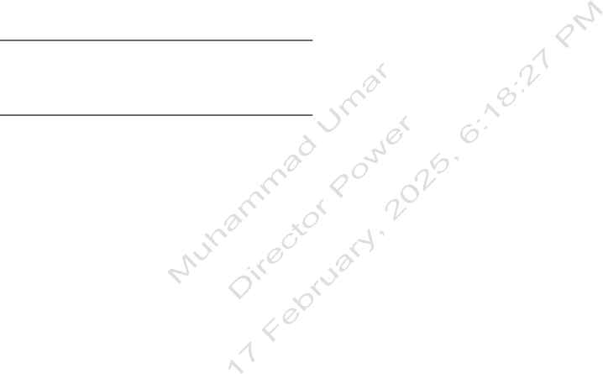
Signature:
Assistant Director (Admin)
Name: Date:

